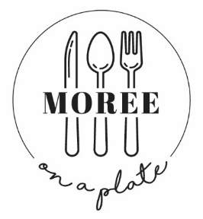
You are invited to attend
Moree On a Plate festival 2022

Moree on a Plate is one of North West NSW’s premier food and wine festivals, having enjoyed 17 successful years celebrating food, wine and the arts in our wonderful community of Moree.

Featuring celebrity chefs, produce from our local businesses and the best in local entertainment, Moree on a Plate is an established community event that consistently provides a wonderful day out the whole family can enjoy.

We are committed to showcasing and promoting our region and its talent and contributing to the rich social fabric of Moree. We are also committed to helping our community.

A safe and successful festival is our top priority, as such this year we ask that with your returned registration form you also provide us with a copy of your businesses COVID-19 safety plan. If you do not already have this document a template can be found on the NSW Government website.

Proposed operating hours for the festival to be open to the public 10am-4pm. Festival hours will be dependent of covid restrictions.

Access to Moree Secondary College, for the festival, is via the gates on Frome Street. The gates will be open for set up at 6:30am and closed at 9:30am. ALL vehicles are to be removed from the school ground by 9:30am. They will then reopen for pack up at 4:15pm. The gates will not be opened between these times unless for Emergency Service Vehicles. In the event that your produce sells out before the end of the festival, you will not be able to leave the grounds until 4:15pm.

We look forward to celebrating your amazing products at this year's festival.

*Power must be requested on registration form. If not stated then a powered site will not be allocated. Electrical uses must be stated on registration form and confirmation from MOP will confirm if you have been allocated your full electrical request.

